9/12/19

Spent the past 8 hours working on a draft page. Used bootstrap and my old code from my other websites. Found an icon to use as a trademark. Found royalty free images to use. Wrote up HTML + CSS.

Icon/Logo <https://www.freefavicon.com/freefavicons/objects/iconinfo/tea-time-152-292243.html>

Images - <https://www.pexels.com/search/restaurant/>

CSS - <https://getbootstrap.com/docs/4.3/getting-started/introduction/>

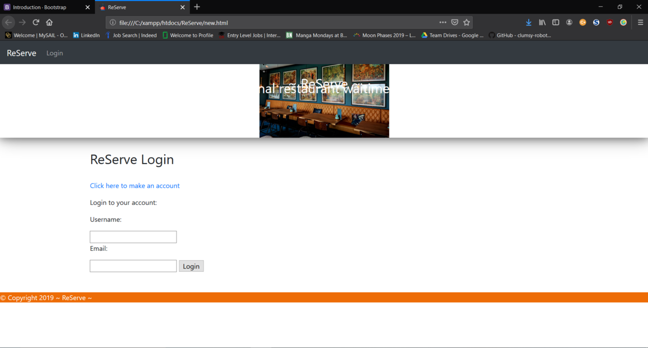

9/14/19  
  
Spent around 4 hours doing research/testing on HTML and CSS the current code is very rough. Collected more icons and images to use.

HTML will need some spacing fixes but all code is working. Created two HTML pages one Main and one Login.

References:

Code - <https://www.quackit.com/html/codes/html_stretch_background_image.cfm>

Code - <https://www.w3schools.com/>

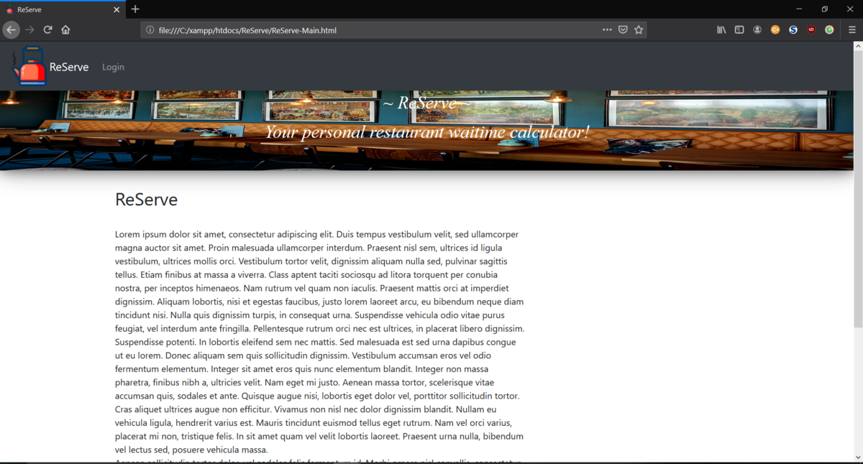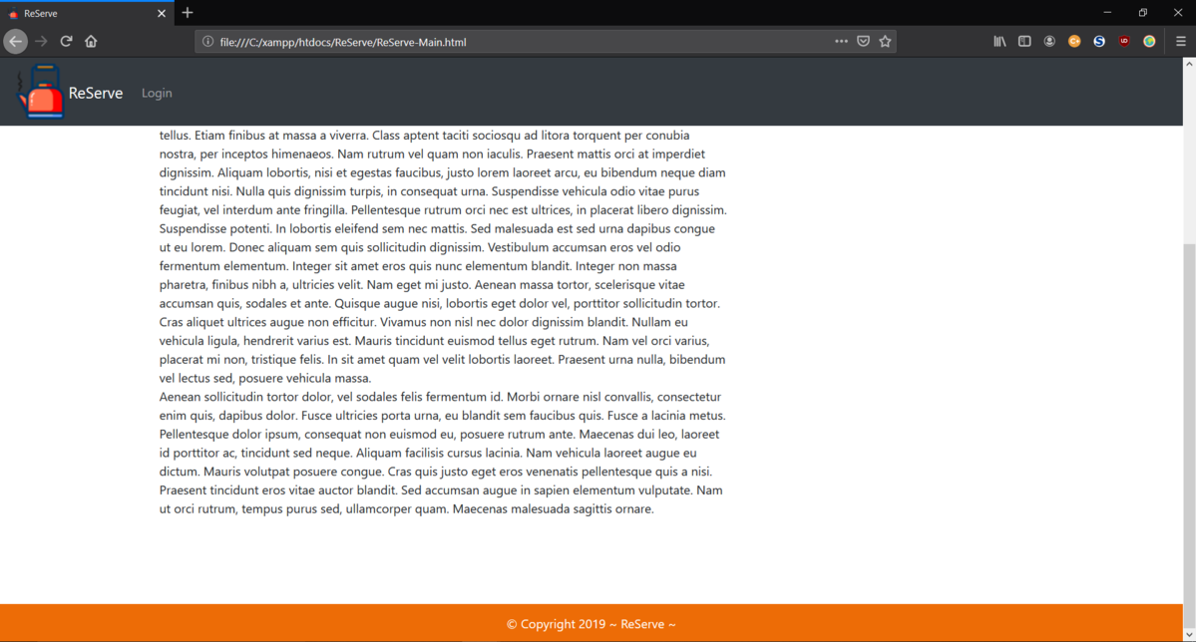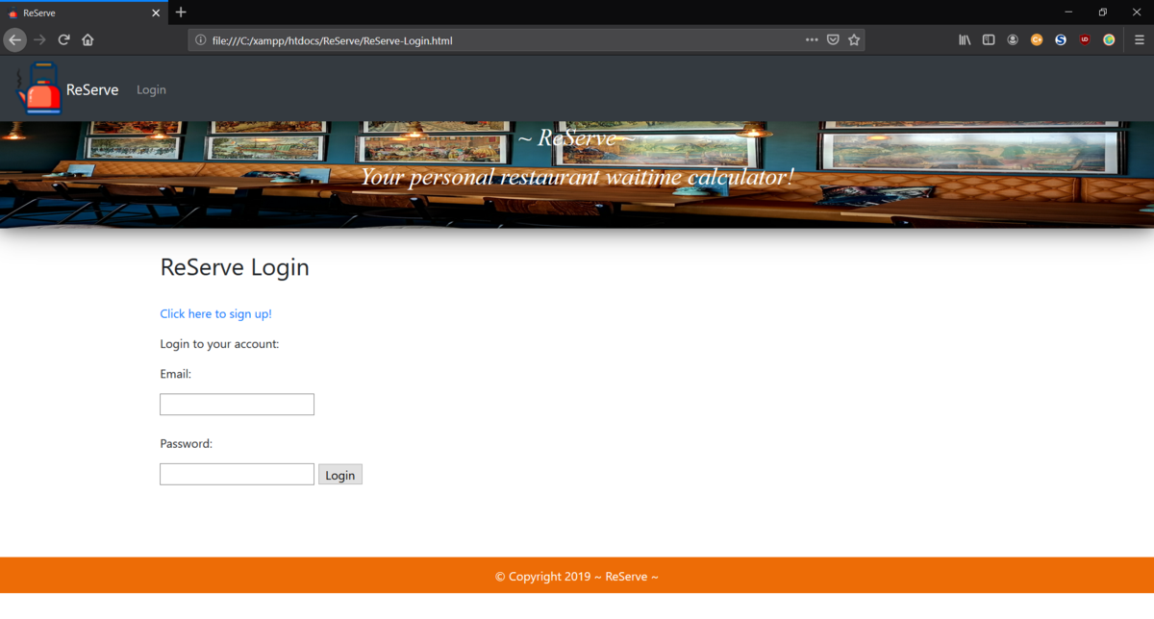  
9/17/19

Spend past 10 hours updating HTML and combining all CSS from RJ's previous three websites, worked on powerpoint, created documentation, cleaned up code so that it is spaced out and commented out correctly.  
  
Code - https://www.wikihow.com/Sample/HTML-Code-for-Space  
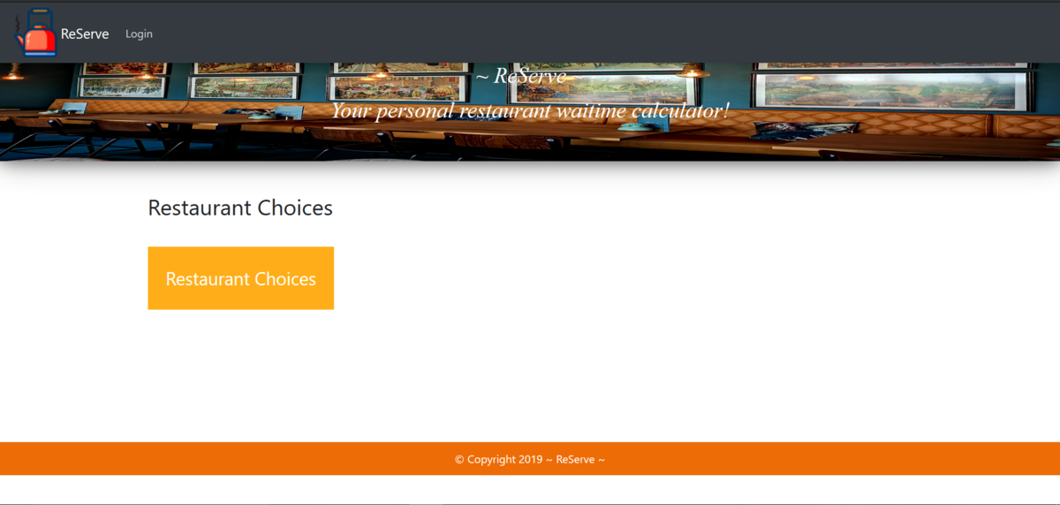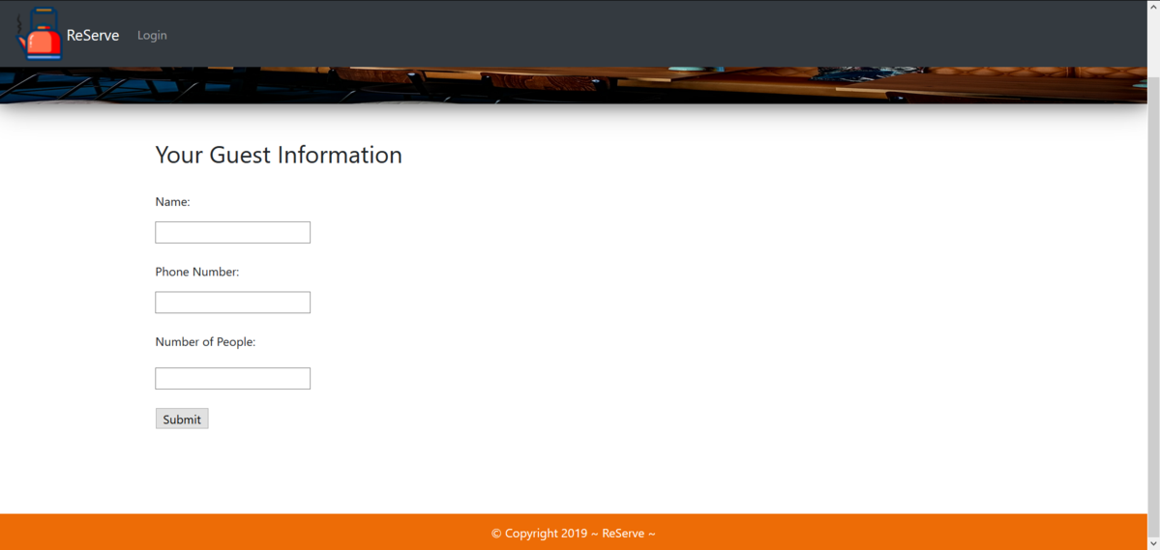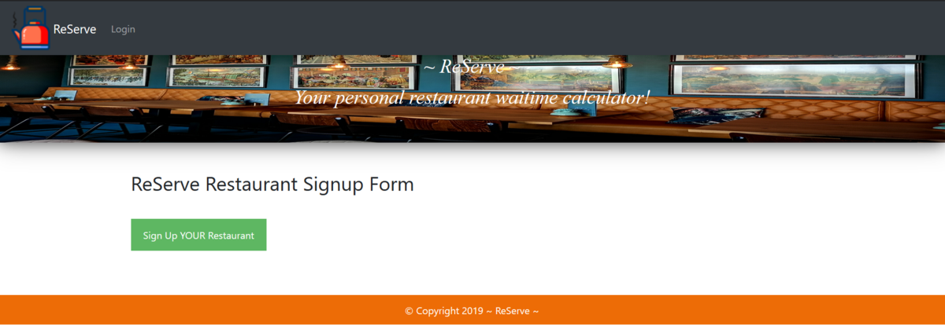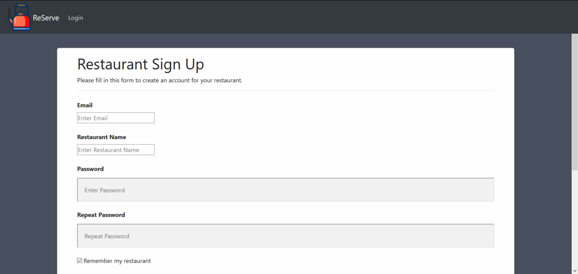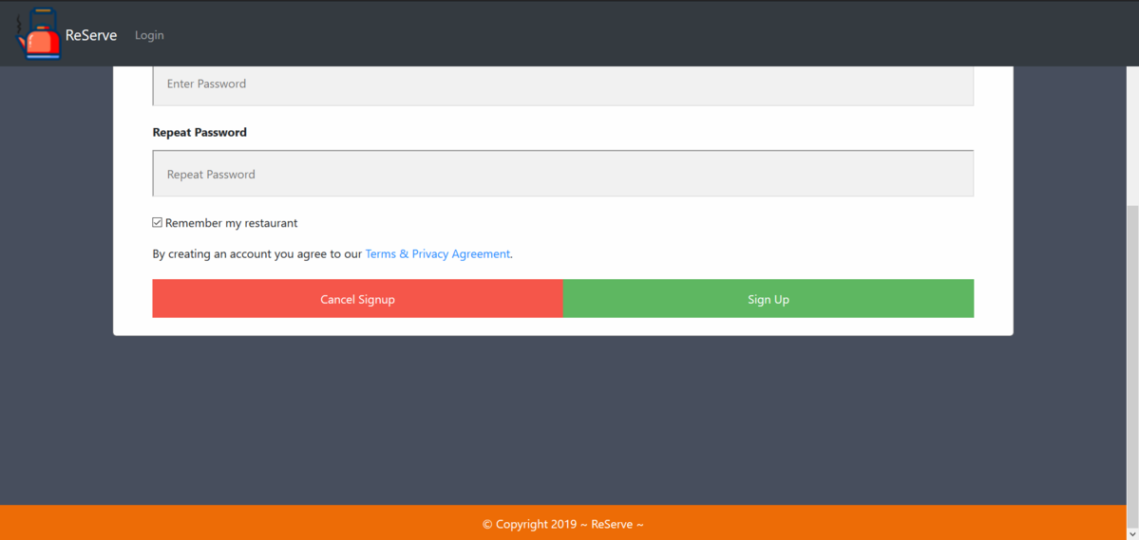  
  
Sprint 2  
9/19/19

Spent 5 hours on the following.

Fixed the banner image code now so that it should be easier to work with in Visual Studios.

Changed coding with spaces between objects so that it works better with VS.

Also added in comments on code and made the code look cleaner.

I figured out how to import the code on Visual Studios.

Committed updated HTML code to github.

Made small edits to the Sprint 2 PowerPoint.

Kelly and I also visited the Tech Office and got approval for a server.

9/24/19  
  
Spent 6 hours on the following.

Navbar fixed on all pages and sizing for tablet/phone adjusted. Other than restaurantSignUpPage.html which I tried to fix but didn't have any luck. All updates on GitHub   
  
  
  
  
  
  
  
  
  
  
  
  
  
  
  
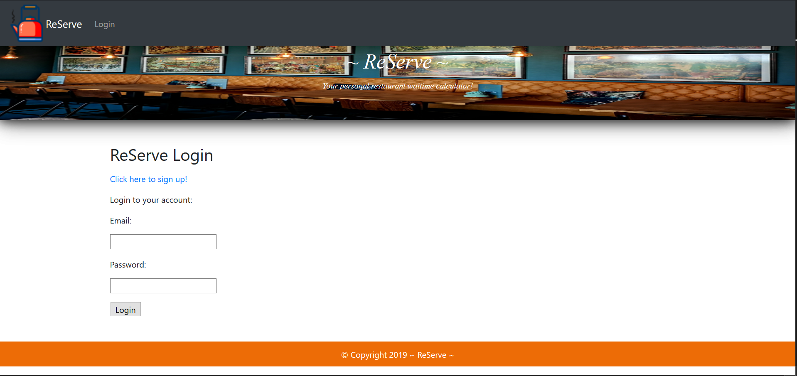  
  
  
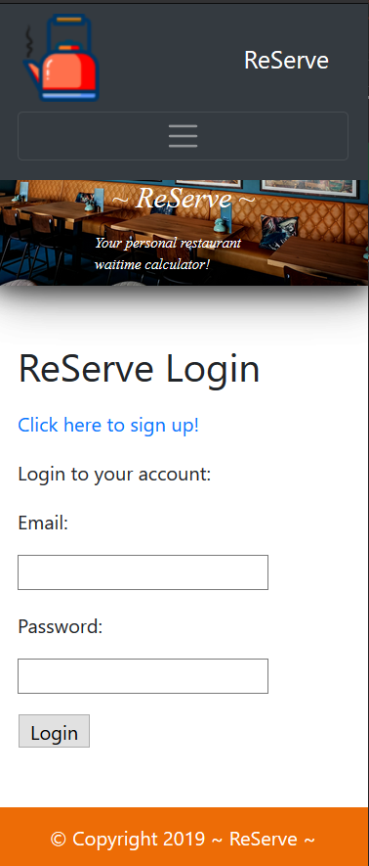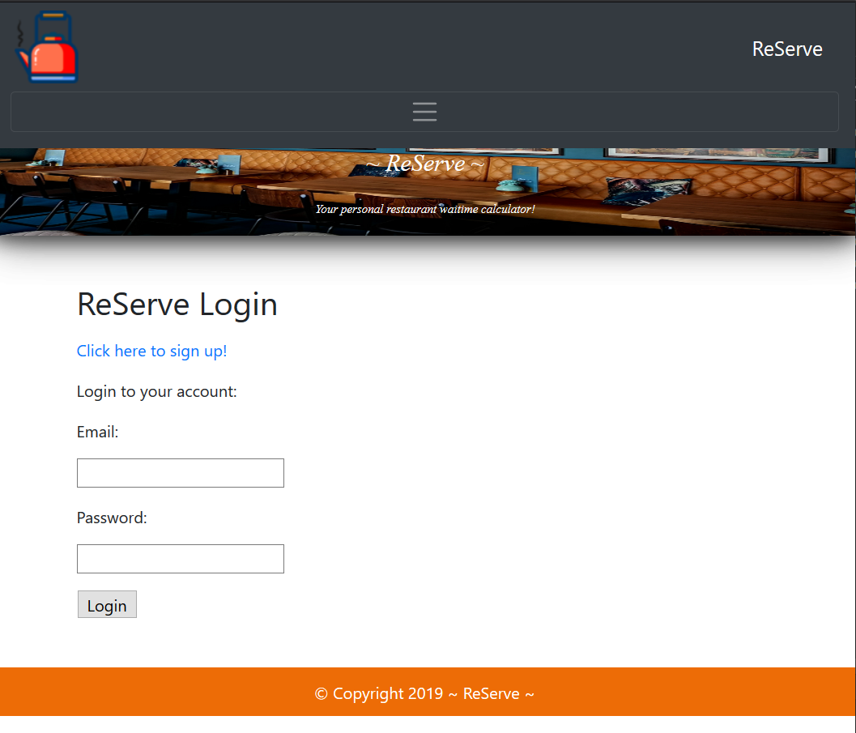  
  
  
  
  
  
  
  
  
  
9/29/19  
Spend 7 hours on the following. Researched how to use a grid system and implemented it. Made a webpage called ReServe-Drag&Drop.html. Found images to use for drag and drop.  
  
<https://www.w3schools.com/bootstrap4/bootstrap_grid_system.asp>  
<https://www.freefavicon.com/freefavicons/objects/iconinfo/check-mark-152-295112.html>  
<https://www.freefavicon.com/freefavicons/objects/iconinfo/green-checkmark--152-312459.html>

